**DAILY ONLINE ACTIVITIES SUMMARY**

|  |  |  |  |  |  |  |  |  |
| --- | --- | --- | --- | --- | --- | --- | --- | --- |
| **Date:** | 25/05/2020 | | | | | **Name:** | D Richard Franklin | |
| **Sem & Sec** | Fourth SEM section A | | | | | **USN:** | 4AL18CS020 | |
| **Online Test Summary** | | | | | | | | |
| **Subject** | | N/A | | | | | | |
| **Max. Marks** | | N/A | | **Score** | | | N/A | |
| **Certification Course Summary** | | | | | | | | |
| **Course** | Complete Python Bootcamp : Go from zero to hero in Python 3 | | | | | | | |
| **Certificate Provider** | | | Udemy | | **Duration** | | | 1 Hour |
| **Coding Challenges** | | | | | | | | |
| **Problem Statement:** 1. Check whether two strings are identical  2. To check whether it’s possible to reach 1 by performing two operations on a number | | | | | | | | |
| **Status:** Completed | | | | | | | | |
| **Uploaded the report in Github** | | | | | YES | | | |
| **If yes Repository name** | | | | | <https://github.com/richard3658/lockdown-coding> | | | |
| **Uploaded the report in slack** | | | | | YES | | | |

**Online Test Details: N/A**

**Certification Course Details:**

**Name of the course**: Complete Python Bootcamp: Go from zero to hero in Python 3

**Certificate Provider**: Udemy

This course has 19 sections and the total duration is 24 hours.

In the seventh day I went through the section of the course that explained about python decorators and python generators and I also had some tasks given by them regarding the topic.

**Snapshot:**

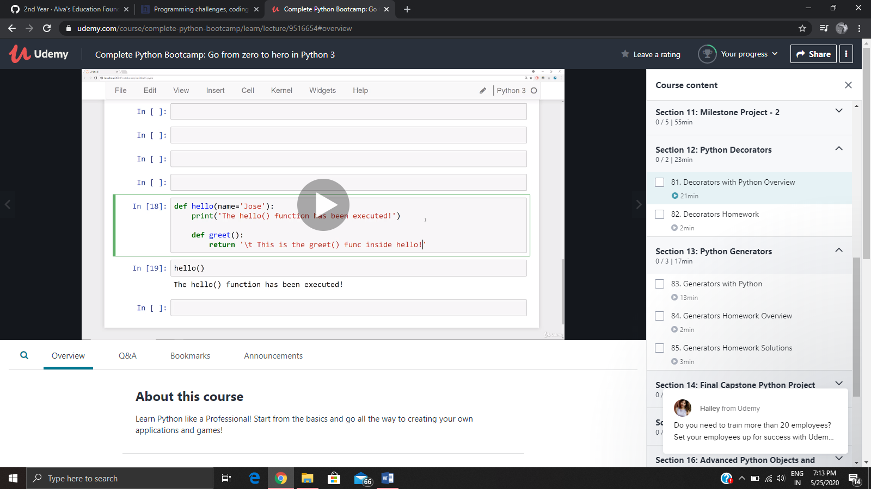

**Online Coding Details:**

Problem 1: (using Python) Given two strings of equal length, you have to tell whether they both strings are identical. Two strings S1 and S2 are said to be identical, if any of the permutation of string S1 is equal to the string S2.

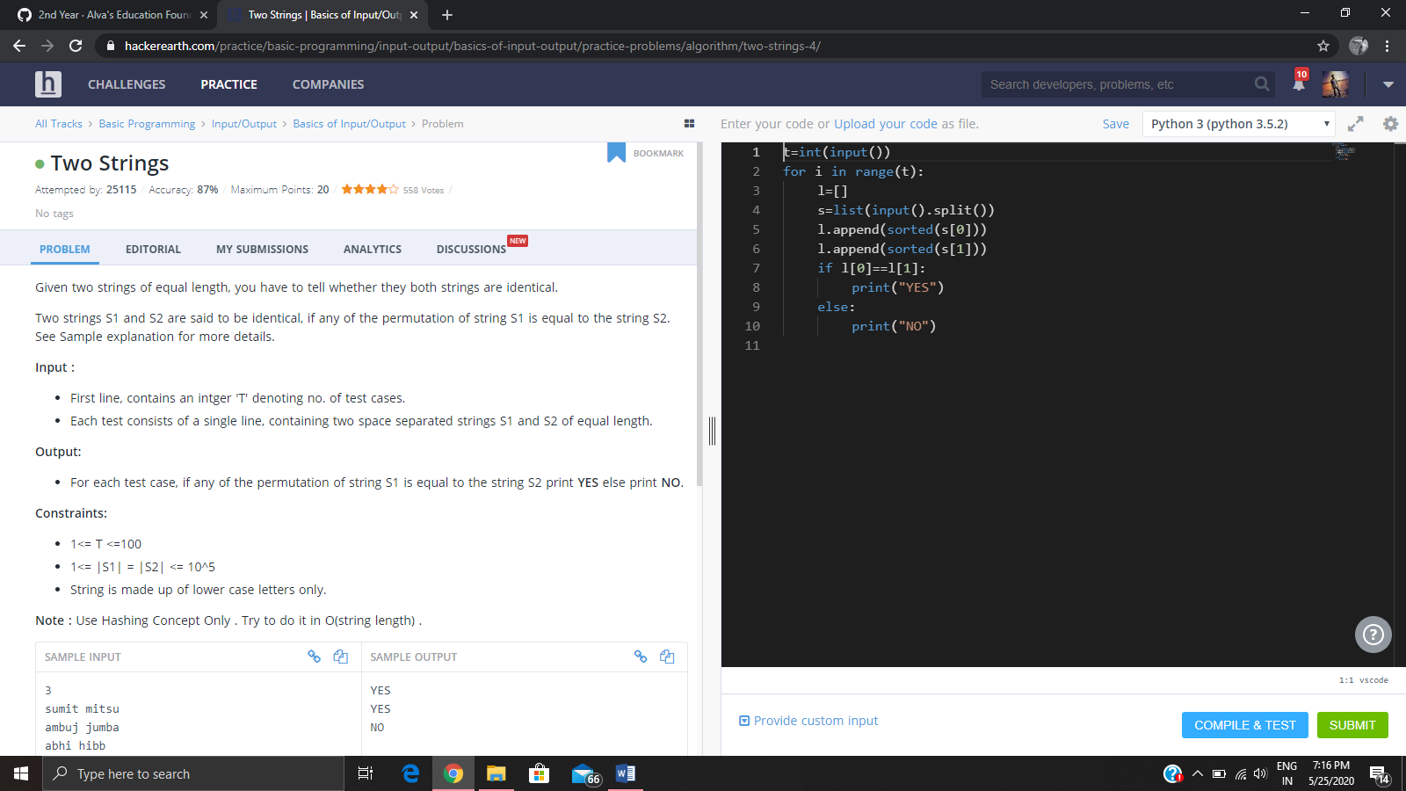

Problem 2: (Using C) You are given a number ***N***. You can perform the following operations on N any number of times:

> If N is***even***, divide N by **2**.

> If N is ***odd***, replace N with **3N+1**.

 Your task is to find out, for a given N, ***if it is possible to reach the number 1*** after performing the above two valid operations on N any number of times.

